**DEPARTMENT OF MECHANICAL ENGINEERING  
  
Subject: Fundamentals of Programming  
Assignment No. 5  
Submitted by: Zahoor Azam  
Registration number: 453972  
Semester No. 1  
Date: October 31, 2023**

**FIRST PROGRAM**

#include<iostream>

using namespace std;

int main()

{int temp,a,b,lcm,hcf,e,f;

cout<<"Enter any two numbers"<<endl;

cin>>a>>b;

e=a;

f=b;

while(f!=0){

temp=f;

f=e%f;

e=temp;

}

hcf=e;

lcm=(a*b)/hcf;

cout<<"Highest common factor "<<hcf<<endl;

cout<<"Least common multiple "<<lcm<<endl;

return 0;

}

**SECOND PROGRAM**

#include<iostream>

using namespace std;

int main(){

int n1, n2, k, q, cd;

int total;

cout<<"sum of arthematic progression : "<<endl;

cout<<"********************************************"<<endl;

cout<<"enter first number of series :"<<endl;

cin>>n1;

cout<<"enter number of terms of series :"<<endl;

cin>>n2;

cout<<"enter commen difference :"<<endl;

cin>>cd;

total=(n2*(2*n1+(n2-1)*cd)/2);

q=n1+(n2-1)*cd;

cout<<"the sum of the the A.P series : "<<endl;

for(k=n1;k<=q;k=k+cd){

if(k!=q)

cout<<k<<" + ";

else

cout<<k<<" = "<<total<<endl;

}

return 0;

}

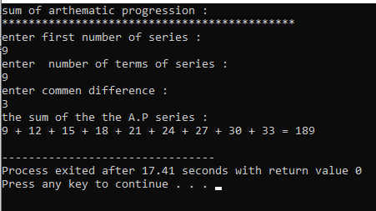

**THIRD PROGRAM**

#include<iostream>

#include<iomanip>

using namespace std;

int main(){

int nos1=4;

int nos2=1;

int nol=4;

for(int i=1;i<=9;i++){

if(i<=5){

for(int j=1;j<=nos1;j++){

cout<<" ";

}

for(int k=1;k<=i;k++){

cout<<setw(2)<<"*";

}

nos1--;

cout<<endl;

} else {

for(int l=1;l<=nos2;l++){

cout<<" ";

}

for(int m=1;m<=nol;m++){

cout<<setw(2)<<"*";

}

nos2++;

nol--;

cout<<endl;

}

}

return 0;

}

**FOURTH PROGRAM**

#include<iostream>

#include<iomanip>

using namespace std;

int main(){

int num,count=0,bin[100];

cout<<"Enter a number of base 10 "<<endl;

cin>>num;

for(int i=0;num>0;i++){

bin[i]=num%2;

num=num/2;

count++;

}

cout<<"Binary equivalent is ";

for(int j=count-1;j>=0;j--){

cout<<bin[j];

}

return 0;

}

